Hello, AAICAMA! Meet us in St. Louis, Missouri for the
2023 AAICAMA Conference.
Full conference, registration, and hotel information below.
JOIN US! • MAY 9 – 11, 2023 at the
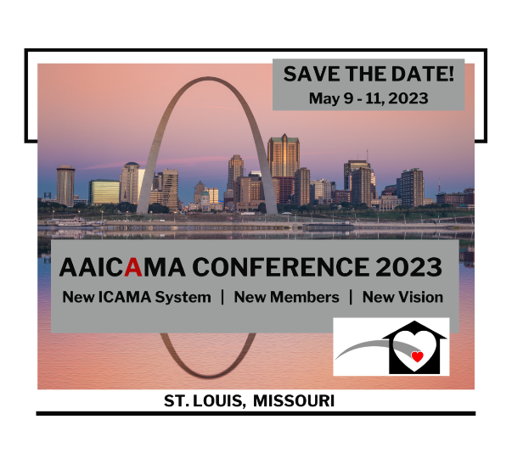
CHARLES F. KNIGHT EXECUTIVE EDUCATION & CONFERENCE CENTER • ST. LOUIS, MO
New ICAMA System | New Members | New Vision

Hello AAICAMA!
The Association and its Executive Board are excited to announce the AAICAMA 2023 Conference to be held May 9 - 11, 2023 in St. Louis, Missouri. Come, join us at the Charles F. Knight Executive Education & Conference Center in education, training, and state exchanges through the forum that is created by and through AAICAMA Members.
The Center is located on the beautiful campus of Washington University. The Hotel is on-site and adjacent to the Conference meeting spaces. Please see Preliminary Agenda, Conference Registration, and Hotel Reservation information below.
- The 2023 AAICAMA Conference is an AAICAMA-only event. The Conference is specially designed for ICAMA Administrators and state, child welfare and Medicaid staff who support the well-being of children and youth from foster care to adoptive permanency. It is being graciously Co-Hosted by the states of Missouri and Illinois and local staff from each state are welcome and encouraged to attend.
- Conf23 will focus on the ICAMA System development project and our new partner and vendor, eCare Vault. We will discuss state practice issues and work together to develop model practices in support of state efforts to administer the Title IV-E and Medicaid programs that meet the special needs of the children we serve.
- To promote and support attendance at Conf23, AAICAMA has created a Conference Attendance Letter. Please contact the AAICAMA National Office for a template of the Letter that your State can tailor to substantiate your participation and receive approval for attendance.
~:~ To Register, please visit: https://AAICAMA-Conf23.eventbrite.com ~:~
Conference Registration includes:
- Full, 2-and-a-half-day Conference Program (see Preliminary Agenda, below)
- Hot, buffet-style breakfast, lunch, and AM & PM snack breaks
- Opening Reception (a portion of total cost) on the evening of Tuesday, May 9th
AAICAMA Preliminary Agenda Conf23
- The ICAMA System (Two sessions: ICAMA System training, development project update
and new vendor/partner, State Q&As.)
- State Practices (Suggestions for model practice, ICAMA System/ICAMA process accountability)
- ICAMA Administrator Training
- Medicaid Training: Securing Services, Ensuring Health
- Advocacy is for All: Advocates for Children’s Benefits/CWLA
- Legislative Update/CWLA
- Self-care: State, child welfare staff
*Finalized Agenda will be sent by email to each registrant and posted on AAICAMA's website.
Schedule Overview
Day One- Tuesday, May 9th | Day Two- Wednesday, May 10th | Day Three- Thursday, May 11th
Breakfast/Registration 7:00–8:30 AM  Welcome, Overview 8:15–8:30 AM  AM 1st Session 8:30–10 AM  AM Break 10–10:15 AM  AM 2nd Session 10:15–11:45 AM  Lunch 11:45–1 PM  Keynote Speaker 1–1:15 PM  PM 1st Session……………… 1:15–2:45 PM  Break 2:45–3 PM  PM 2nd Session 3–4:30 PM  Review of the Day 4:30–4:45 PM  Opening Reception 6:30 PM | Breakfast……………..…..7:00–8:30 AM  Welcome, Overview……..8:15–8:30 AM  AM 1st Session……….…..8:30–10 AM  AM Break…………………10–10:15 AM  AM 2nd Session……….....10:15–11:45 AM  Lunch……………………..11:45–1 PM  PM 1st Session…………...1:15–2:45 PM  Break………………………2:45–3 PM  PM 2nd Session…………...3–4:30 PM  Review of the Day………..4:30–4:45 PM  Board Meeting…………….5:30 PM  Dinner on your own | Breakfast………………...7:00–8:30 AM  Welcome, Overview........8:15–8:30 AM  AM 1st Session……….….8:30–10 AM  AM Break………………...10–10:15 AM  AM 2nd Session……….…10:15–11:45 AM  Lunch *.…………………..11:45–1 PM  Closing Plenary….……....1:15-2PM  * Head count needed by end of Day One
Sessions held in Room 340, 3rd floor; Food served in Bear Lounge, 3rd floor
JOIN US! Be a part of the Association's annual exchange of ideas, innovation, and training that is the forum created by convening states for the AAICAMA Conference.
CONFERENCE REGISTRATION: Early Bird Rate: $695; General Registration: $745; Late Registration: $795; On-site Registration: $825. Please see: Registration & Payment Instructions.
HOTEL RESERVATION AND INFORMATION: A block of hotel rooms has been reserved for AAICAMA at the Charles F. Knight Conference Center at the federal, per diem rate on a first-come, first-served basis. Space is limited. To make your Hotel Reservation, please call the Center directly: (314) 933-9400 or Email them your reservation request at: Knightfrontdesk@olin.wustl.edu.
~:~ To Register, please visit: https://AAICAMA-Conf23.eventbrite.com ~:~
Registration & Payment Instructions
Please complete a separate, online registration for each person attending the conference. All advance registrations must be paid by check, credit card, or signed Purchase Order authorizing conference registration payment by Friday, April 28, 2023, unless arranged in advance with the National Office. All onsite registrations must be made by check or credit card.
Please submit documentation to your agency early enough to ensure that AAICAMA receives a guarantee of payment on or before Friday, April 28, 2023, unless arranged in advance with the National Office.
All payments are due by Friday, April 28, 2023, unless arranged in advance with the National Office. Make checks payable to AAICAMA and mail to 727 15th Street NW, Suite 1200, Washington, DC 20005. To pay by credit card offline, please call the National Office, Executive Coordinator: Charlene Haskell (202) 963-8754. Purchase Orders will be accepted for pre-registration. If paying by check, your agency’s check must be received by Friday, April 28, 2023, unless arranged in advance with the National Office. AAICAMA encourages you to make sure payment has been received by the National Office prior to the start of the conference.
Special note for Host States, Missouri and Illinois: ICAMA support staff, to include child welfare, Medicaid, and post-adoption colleagues may receive discounted registration rates. Please contact the National Office for more information and direct registration.

Cancellation Policy
Previously paid registrations. Cancellation: Written notice of cancellation of previously paid registrations must be received and confirmed by e-mail to Charlene Haskell, Executive Coordinator, at CHaskell@aaicama.org by Friday, April 28, 2023, to receive a full refund, less a $75 processing fee. After Friday, April 28, 2023, refunds will be unavailable.
Previously paid registrations. “No shows”: If the registrant is unable to attend the conference, and AAICAMA has not received written notice of cancellation of a previously paid registration by email to Charlene Haskell, Executive Coordinator, at CHaskell@aaicama.org by Friday, April 28, 2023, 25% of the registration fee will be remitted to the registrant.
Previously unpaid registrations. Cancellation: Written notice of cancellation of previously unpaid registrations must be received and confirmed by e-mail to Charlene Haskell, Executive Coordinator, at CHaskell@aaicama.org by Friday, April 28, 2023, to receive a full refund, less a $75 processing fee. After Friday, April 28, 2023, refunds will be unavailable.
Previously unpaid registrations. “No shows”: If the registrant is unable to attend the conference, and AAICAMA has not received written notice of cancellation of an unpaid registration by email to Charlene Haskell, Executive Coordinator, at CHaskell@aaicama.org by Friday, April 28, 2023, a $75 processing fee will be charged to the registrant.
Substitutions: If you are not able to attend, you may send a substitute from your state, but the request must be received and confirmed with the AAICAMA National Office by Friday, April 28th by emailing Charlene Haskell, Executive Coordinator at CHaskell@aaicama.org.
Hotel Reservations
Hotel charges are not included in the conference registration fees. A block of hotel rooms has been reserved for AAICAMA conference participants at the Charles F. Knight Conference Center at the federal, per diem rate ($141) plus taxes, on a first-come, first-served basis. Space is limited. To access the room block, reservations must be made by Monday, April 17, 2023.
To make your hotel reservation, please call the Center directly: (314) 933-9400 or email your reservation request to: Knightfrontdesk@olin.wustl.edu.

Registration Terms
AAICAMA reserves the right to change or cancel sessions or presenters as needed.
AAICAMA, its staff or contractors may request to photograph or videotape sessions and events at the conference. By attending the conference, attendees understand that their images may be used by AAICAMA in its publications, website, or marketing and promotional materials. Please inform the National Office if you have any questions or concerns.
All liability of the Association of Administrators for the Interstate Compact on Adoption and Medical Assistance (AAICAMA) with respect to attendance, registration, reservations, cancellations, changes in the location or content of the program, and refunds is limited to a sum no greater than the registration fee paid. Under no circumstances shall AAICAMA be liable for incidental or consequential damages of any kind, including, but not limited to, the cost of transportation or lodging. Conference attendee waives all claims of any kind against AAICAMA and its respective employees and agents arising from their participation in the conference. The attendee further agrees to defend, indemnify, and hold harmless AAICAMA and its respective employees and agents from all damages, claims, or other liabilities resulting from any act or omission connected with attendee’s participation in the conference. The attendee’s liability shall include all losses, costs, damages, or expenses arising from or out of or by reason of any accident or bodily injury or other occurrences which result from or out of the attendee’s participation in the conference. Attendees agree to adhere to all health and safety requirements mandated by hotel and local/state jurisdictions.

Submission of registration and payment constitutes acceptance of the above terms and conditions.

Please contact the AAICAMA National Office if you have any questions:
- Charlene Haskell, Executive Coordinator: (202) 963-8754; CHaskell@aaicama.org
- Sharon McCartney, Director: (202) 913-3226; SMcCartney@aaicama.org

Permanency Matters! TeamAAICAMA!

